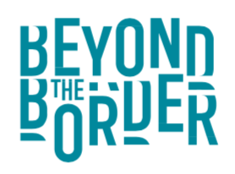
New Voices Mentoring Programme 2020
Application Form

Name
DOB
Address
Email address
Phone number
Please give us a brief outline of your storytelling experience to date.
This could include how you first became interested in storytelling, what kind of stories you tell, and where you tell stories.

In what way will this programme help to develop your voice as a storyteller?
What training needs do you think you have? How could the festival help to support you? If you’re already telling stories regularly in a story club but you would like to start developing yourself as a professional storyteller, it might be that you want support to start monetising your work, or developing a longer piece for performance. If you’re new to the art form, it might be that you want support in developing introductory storytelling techniques. If you’re already working professionally as a storyteller, perhaps you want to develop a particular storytelling skill or area of your work.

Do you have a Mentor or Mentors in mind already that you might like to work with?
These Mentors will be established storytellers or – in specific cases – could also be people working in a different field who may help you to develop a particular skill as a storyteller.

How will you continue to develop your voice as a storyteller once the programme ends?
We would like to know what the legacy of this programme might be. Do you eventually intend to work as a storyteller? Or will you use storytelling in your work in some way?

Please send us a short film of yourself telling a traditional story, ideally shorter than 5 minutes. You can send the film via WeTransfer to tamarwilliams@beyondtheborder.com.
Deadline 3 August 2020

