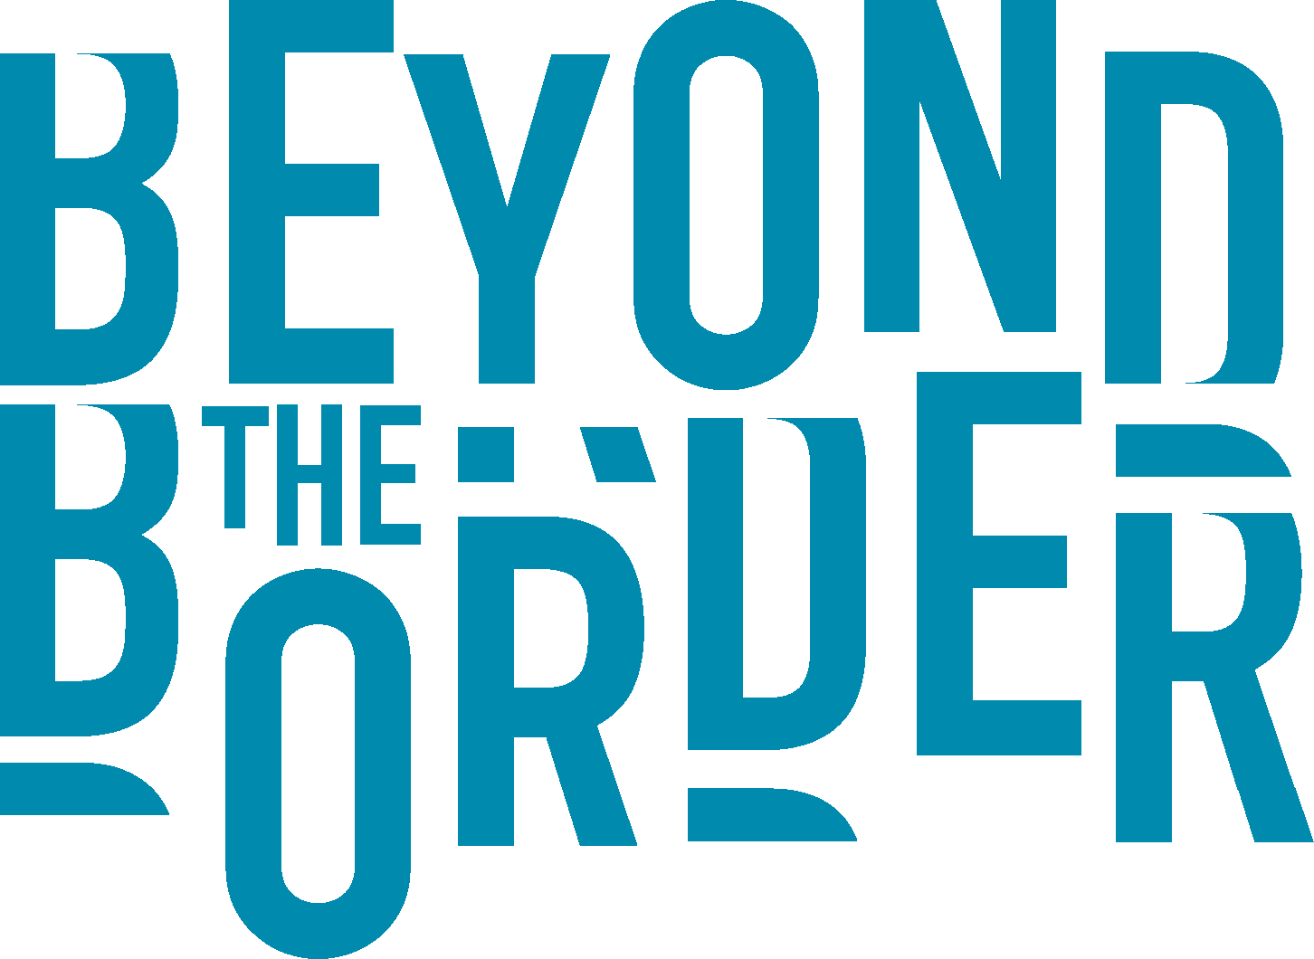

JOB TITLE | Festival Coordinator
LINE MANAGER | Festival Manager

Beyond the Border Storytelling Festival is looking for a freelance Festival Coordinator to assist the Festival Management, Operations and Production Management teams to deliver a successful festival in July 2021 at its new site at National Trust Dinefwr.

Job description:
Working as part of the BTB team to deliver a successful festival against established Board targets of financial success, customer experience, partnership development, performer experience, volunteer experience, trader experience.

To assist in the coordination and administration of artists requirements for the festival including liaising with artist director, festival manager, operations and production management team and ensuring specifications and information are successfully communicated to relevant groups,

To assist in the coordination and administration of Volunteers information

To assist the Festival Manager in coordination and administration of schedules during the festival including artists and volunteers including liaising with management teams

To assist in the coordination of contractual obligations with individuals, companies and contractors with regards to delivery of festival including freelance staff, artists, suppliers, traders,

To assist the Festival Manager in ensuring all local and national government processes are followed in delivery of festival in terms of safety including Covid guidelines, compliance, MEU targets

Working with Management Team to ensure collection of information for reporting and evaluation to Board, relevant organisations and funding bodies and to funding bodies.

Skills and Knowledge
Essential | - Excellent interpersonal and communication skills  - Understanding of production and technical requirements for performance storytelling  - Strong organisational and administration skills – Excel,  Googledrive.
Desirable | - Understanding of digital performance tools and platforms
Experience
Essential | - Arts events experience including digital events  - Artist liaison  - Demonstrable coordination and administrative experience  - Working as part of team  - Customer care
Desirable | - Experience of working within a fully bilingual environment  - Experience of working in an arts festival environment
Personal attributes and attitudes
Essential | - Ability to work independently  - Calmness under pressure  - Attention to detail  - Commitment to equality, diversity and accessibility  - Willingness to work flexibly  - Ability to create positive working relationships
Desirable | - Understanding of and a commitment to storytelling as an art form  - Understanding of and a commitment to promoting intercultural understanding

The Organisation
Beyond the Border Wales’ International Storytelling Festival is a unique cultural event in Wales: the only international storytelling festival in the country, the leading festival of its kind in the UK, and regarded as one of the finest international storytelling festivals in the world. It has upheld the strong BtB brand with its reputation for excellence, international collaboration, inclusivity and intelligent, creatively themed programming, as well as providing a platform for Wales and Welsh culture to be seen and experienced at the centre of the international storytelling stage.
The festival is delivered by Beyond the Border Storytelling Festival ltd, a registered company and charity with stated charitable objects:
“To advance the education of the public, in particular but not exclusively, those living in Wales, in storytelling and related arts and to further the public appreciation and taste in storytelling and related arts.”

NT Dinefwr was selected as the new home for the festival and significant public funds were awarded for its 2020 festival. Beyond the Border’s management team includes Naomi Wilds as Artistic Director, Sandra Bendelow as Festival Manager, Tamar Eluned Williams as Engagement Manager and Suzanne Carter as Marketing Manager. In addition BTB employs a freelance team to deliver the Festival biennially managing Operations, Technical and Production.

Following the pandemic the decision was made to postpone the first festival at Dinefwr to 2021 and though it will be a smaller event to allow for current Covid guidelines the team are fully committed to making a festival happen in 2021 which though smaller will be no less ambitious. The smaller physical festival will be augmented by a virtual festival which will be equally ambitious in scope and exploration seeking to take audiences who cannot attend the festival to the NT Dinefwr festival site. During the postponement year the team have continued to secure resilience and cultural recovery to create projects with freelance storytellers in Wales. These projects exploring a range of key subjects including storytelling working with heritage, language, environment, accessibility and digital tools and platforms and have created a series of ambitious strategies for the next six years.

Place of work
It is expected that the FC will work from home and provide facilities such as their own computer, printer, broadband connection and telephone. An office will be set up on site in the immediate run up to the festival.

While much of the work could be undertaken anywhere, throughout the contract site visits may be required.

Contract
The appointment will start as soon as possible and complete on 23rd July. The Festival will take place 2-5 July and the festival build will begin on 26th June and will be off site by 8th July. A Virtual Festival will run from 19th June to 17th July.

A notional daily rate of £150 has been used to create the budgetary cost line for this contract, however it is offered on a ‘job done’ basis for an agreed sum. Time needs to be worked flexibly, with the expectation of sufficient time being allocated to support co-ordination of the event with an expectation of a significant time commitment around the event itself. Remuneration offered is £5,000.

Equality and Diversity
BTB is committed to working beyond borders and removing barriers to accessibility to storytelling through in its artistic strategy, it’s policies and practices. It operates an Equal Opportunities Recruitment Policy and welcomes applications from all sections of the community in Welsh or English.

How to apply
A letter of application detailing how you meet the person specification, an accompanying CV, and the names of two referees should be emailed to info@beyondtheborder.com. We suggest you request a “read receipt” so that you are assured that is has arrived safely.

Your application should arrive no later than 5pm on 26th April 2021.

Interviews will be held on line shortly afterwards, date tbc.

Beyond the Border Storytelling Festival Ltd
Baltic House
Mount Stuart Square
Cardiff, CF10 5FH

Company number 7534036 Charity No 1144275

