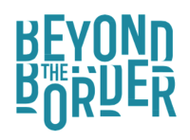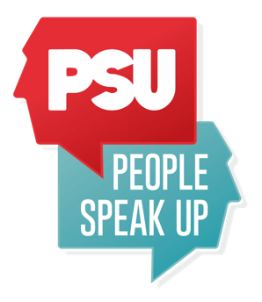

Anti – Racism Storytelling Pathways

Role: Project Manager (freelance post)
Start: February 2023 (72 days @ £200 per day until the end March 2024)
12 days for Feb 23 to March 23 for start up period, 60 days for year 2
Initial Contract until: March 2024

The Anti-Racism Storytelling Pathways project is a joint collaboration between Beyond the Border Wales International Storytelling Festival and People Speak Up. The project connects with the Mycelium Storytelling Hub project, embedding storytellers and producers across Wales, and also includes organisational development and action planning across both organisations. We are seeking a Project Manager with lived experience of racism to steer the project, manage the creative roles being recruited and ensure the project achieves its objectives, in partnership with teams at both organisations.

Job Purpose
- To manage the project to achieve its aims, to develop co-created cultural programmes which celebrate the rich and diverse stories of our shared heritage.
- To ensure both organisations initiate artform-focused anti racist training and organisational anti-racist action plans, working actively and assertively to be anti-racist.
- To provide support to Cyfarwyddion and Producer recruited for the project, and to engage with advisors, panels and mentors recruited to support the project
- To manage project budget and gather data, fulfilling the administrative requirements of the role.

Main Duties and Responsibilities
- Work in collaboration with Beyond the Border and People Speak Up to manage the project as set out in the project plan and budget
- Develop opportunities that will increase anti-racist provision, in relation to storytelling practice across Wales
- Support postholders

Operational Responsibilities
- To work in collaboration with Beyond the Border and People Speak Up to manage the project as set out in the project plan and budget
- To support recruitment of Cyfarwyddion x 2 and Producer x 1 by end of March 2023
- To develop a growing database of Black, Asian and minority ethnic decision makers, creatives, consultants and mentors to support delivery of the plan, integrated into both organisation’s programmes
- To initiate anti-racist training for staff, board and volunteer teams at both organisations, reviewing and updating reporting systems for experiences of racism and discrimination
- To create accountable anti-racist plans in partnership with teams at both organisations
- Providing artform-specific anti-racist training for artists and producers, addressing cultural appropriation and othering, stereotypes, and discrimination in storytelling, providing mutual support and accountability to enable best practice
- Supporting local and Wales-wide showcase events celebrating Wales’ diverse cultural heritage, including international Global Majority diaspora creative projects, co-created with Cyfarwyddion/Producers.
- Identify funding streams for potential continuation/expansion of the work
- Provide day to day administrative and communication support for the project
- Manage budget associated with the project
- Fulfil all admin, data monitoring and evaluation requirements of the post

Person specification
Essential
- Experience of managing arts projects
- Experience of supporting organisational development
- Experience of supporting creative practitioners
- Budget management experience
- Strong administration, IT and communication skills
- Experience of working with participants of all ages and abilities in the arts
- Ability to create positive working relationships with a wide range of individuals, organisations and stakeholders
- Well organised with a flexible and proactive approach to work and the ability to work to deadlines whilst prioritising a varied workload
- Willingness and ability to work both independently and as part of a team
- Able to use own initiative as well as work within provided guidelines
- Access to own computer, printer and telephone
- Understanding and commitment to equal opportunities, diversity and access
DESIRABLE SKILLS
- Interest in spoken word and storytelling
- Good knowledge and experience of using social media platforms and online engagement strategies
- Good research skills
- Capacity to evaluate activity
- Lived experience of racism
The role is ring-fenced for Black, Asian and minority ethnic candidates. This is based on a commitment to anti-racist practice and reflects under-representation in our sector which we want to address.

To apply, please send your CV and a 1 x A4 page letter explaining how you meet the person specification and what you will bring to the role. You can also apply by video, filming yourself answering these questions.

Please send your application to recruitment@beyondtheborder.com by Sunday 12 February at 5pm.
We will be holding an online webinar to share information about the project and the jobs available on these dates:
Tues 7 February, 7 – 8pm
Thurs 9 February, 7 – 8pm on Zoom.
To book your place email recruitment@beyondtheborder.com
Anti-Racism Storytelling Pathways has been made possible with funding from Welsh Government's Anti-Racist Wales Culture, Heritage and Sport Fund

