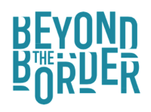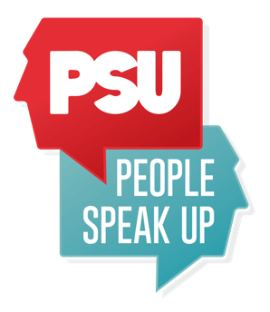

Anti – Racism Storytelling Pathways

Advisory Panel Members/Advisors/Mentors
Looking for three people to support recruitment, plus pool of experts over life of project

Brief: Beyond the Border - Wales International Storytelling Festival and People Speak Up are seeking expressions of interest from Wales based Black, Asian and minority ethnic advisors, to participate in this two year project as panel members and mentors. Roles will be reimbursed at a rate of £250 per day (based on 7.5 hour days) for up to five days for the recruitment and advisory phase up to end of March 2023 (three practitioners) with additional fees available for 2023-24.

Support required will include:
- Providing advice and guidance to organisations on suitable consultants, community advocates and artform practitioners to involve in this and wider organisational programmes

- Supporting recruitment and decision making for the following roles, contributing to shortlisting and interview panels for:
  - 2 x Contemporary Cyfarwyddion (Black, Asian or minority ethnic practitioners), storytellers/spoken word artists. These artists will develop a programme of storytelling activity, including storytelling performances and engagement, which reaches more widely and deeply into communities where they choose to locate and base an 18 month residency. Communities where they base may be geographic, but may also be communities of shared experience, identity, or circumstance.
  - 1 x Producer – (Black, Asian or minority ethnic practitioner) who will support the above two roles and an Associate Cyfarwyddion based at PSU, working to build community partnerships and co-produce creative projects over the course of these posts
  - Project Manager – (Black, Asian or minority ethnic practitioner) to provide overall project management for the 2 year plan, including managing creative residencies, anti-racism action planning, budget, evaluation, data capture and reporting on targets as a team member at Beyond the Border (working from home). Includes potential to fundraise to extend the project.

- Acting as advisors, mentors and sounding boards throughout the life of the project

To express interest: please send us a short video/audio clip (3 mins) or a 1 x A4 outline of why you would like to participate and what you can bring to the role by 31 January 2023.

We will also be holding an online open conversation about the project and the roles on Tues 27 January from 11 – 12 noon. To book your place email recruitment@beyondtheborder.com

Email your interest to recruitment@beyondtheborder.com

Time Commitments:
Week of 6 Feb: Supporting online info sharing session for creative & project manager roles (maximum 2 hour evening session)
Week of 13 Feb: Shortlisting applications for Project Manager role (0.5 days)
Week of 20 Feb: Part of interview panel for the PM role (0.5 day)
Week of 6 March: Shortlist for Cyfarwyddion and Producer roles (1 day)
Week of 13 March: Interview for Cyfarwyddion and Producer roles (1 day)
Contingency: General Advice 1.5 days

Anti-Racism Storytelling Pathways has been made possible with funding from Welsh Government's Anti-Racist Wales Culture, Heritage and Sport Fund

